**Supplementary Materials**

**to “**Integrated high-resolution, continental-scale modelling for forecasting land change”

**Marco Calderón-Loor1,2*, Michalis Hadjikakou1**, **Richard Hewitt3, Raymundo Marcos-Martinez4, Brett A Bryan1**

1 Centre for Integrative Ecology, School of Life and Environmental Sciences, Deakin University, Melbourne, Australia

2 Grupo de Investigación de Biodiversidad, Medio Ambiente y Salud–BIOMAS, Universidad de las Américas (UDLA), Quito, Ecuador

3 Transport, Infrastructure, and Territory Research Group (t-GIS), Geography Department, Faculty of Geography and History, Universidad Complutense de Madrid (UCM), C/ Profesor Aranguren, s/n, 28040 Madrid, Spain

4 Commonwealth Scientific and Industrial Research Organisation (CSIRO), Canberra, Australia

*Corresponding author

Email: [mcalderonloor@deakin.edu.au](mailto:mcalderonloor@deakin.edu.au)

We present the following supplementary materials:

Table S1:Error matrix for Australia’s 2015 land-use maximum-likelihood prediction.

Table S2:Overall validation accuracy for the year 2015 land-use maximum-likelihoodprediction at State and SA2 level.

Figure S1: Land-use class ROC curve for the maximum-likelihood allocation procedure per State: A) New South Wales; B) Victoria; C) Queensland; D) South Australia; E) Western Australia; F) Northern Territory; G) Tasmania; and, H) Australian Capital Territory.

*Table S1: Error matrix for Australia’s 2015 land-use maximum-likelihood prediction.*

|  | Cropland | Forest | Grassland | Built-up | Total | UA (%) | CE (%) |
| --- | --- | --- | --- | --- | --- | --- | --- |
| Cropland | 747,150,606 | 41,577,510 | 30,785,511 | 10,616,466 | 830,130,093 | 90.0 | 10.0 |
| Forest | 60,700,626 | 2,028,825,062 | 86,150,350 | 12,661,354 | 2,188,337,392 | 92.7 | 7.3 |
| Grassland | 217,987,397 | 454,083,138 | 5,586,648,705 | 11,418,787 | 6,270,138,027 | 89.1 | 10.9 |
| Built-up | 325,896 | 201,179 | 133,325 | 19,419,698 | 20,080,098 | 96.7 | 3.3 |
| Total | 1,026,164,525 | 2,524,686,889 | 5,703,717,891 | 54,116,305 |  |  |  |
| PA (%) | 72.8 | 80.4 | 97.9 | 35.9 |  |  |  |
| OE (%) | 27.2 | 19.6 | 2.1 | 64.1 |  |  |  |

Where: PA: Producer Accuracy; UA: User Accuracy; CE: Commission Errors; OE: Omission errors.

*Table S2: Overall validation accuracy for the year 2015 land-use maximum-likelihood prediction at State and SA2 level.*

|  | Overall accuracy (%) | |
| --- | --- | --- |
|  | State | SA2 (± SD) |
| New South Wales | 82.2 | 41.9 (34.8) |
| Victoria | 86.6 | 34.8 (36.3) |
| Queensland | 82.5 | 34 (32.2) |
| South Australia | 95.1 | 40 (36.1) |
| Western Australia | 94.4 | 34 (37.3) |
| Tasmania | 89.1 | 55.7 (29) |
| Northern Territory | 93.5 | 45.7 (40.3) |
| Australian Capital Territory | 85.7 | 1 (20.7) |

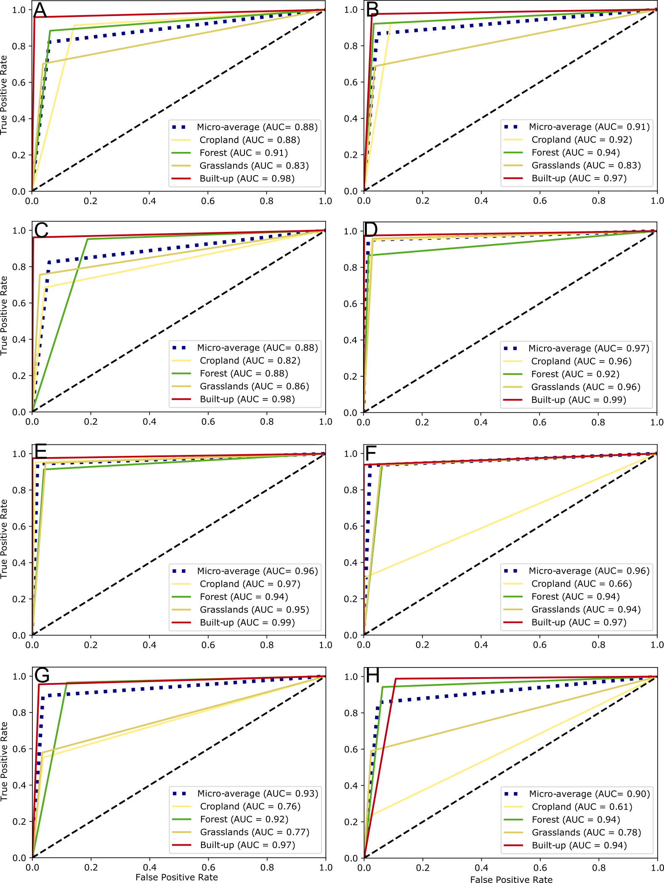

*Figure S1: Land-use class ROC curve for the maximum-likelihood allocation procedure per State: A) New South Wales; B) Victoria; C) Queensland; D) South Australia; E) Western Australia; F) Northern Territory; G) Tasmania; and, H) Australian Capital Territory.*